Software Specification

11th of March 2015
2IO70
Version 1.0

The purpose of this document is to give an as accurately as possible description of the required behaviour of the PP2, without describing how this is achieved, and a UPPAAL model of this behaviour. In order to do this, we translate the system level requirements to a high level specification of what the software controlling the physical machine should do.

Group 16
Rolf Verschuuren
Wigger Boelens
Stefan van den Berg
Dat Phung
Maarten Keet
Tudor Petrescu
Table of Contents
Inputs and Outputs 3
Inputs 3
Outputs 3
Relations 3
Lens lamp of the black white detector 3
Lens lamp of the position sensor 3
Engine of the conveyer belt 3
Engine of the feeder 3
Engine for the sorter 3
Display for counting 4
Description of States 5
State transitions 9
Finite state Automaton 10
UPPAAL model 11
Validation and Testing 12

Inputs and Outputs

Inputs
[Insert table of inputs to the program]

Outputs
[Insert table of outputs from the program]

Relations

Lens lamp of the black white detector
The lens lamp of the black white detector will go on when the disc is expected at the sensor. We can calculate when we expect a disc according to the speed of the conveyer belt and the input of the photo transistor of the position sensor. The lens lamp goes on when the timer hits calculates time of arrival.

Lens lamp of the position sensor
The lens lamp of the position sensor reacts only to the “START/STOP” button and the “ABORT” button. The lens lamp will be on after the “START/STOP” button is pressed and the machine is in its resting state. If at any other point in time the “ABORT” button is pressed it will go off. When the “START/STOP” button is pressed and the machine is running then the lens lamp also goes off.

Engine of the conveyer belt
The engine of on the conveyer belt only reacts to the input of the “START/STOP” button and the “ABORT” button. The engine will start when the machine is in its resting state and the “START/STOP” button is pressed. If however the “START/STOP” button is pressed and the machine is not in its resting state then the machine will stop after it completed its current cycle. Whenever the “ABORT” button is pressed the engine stops within 50ms.

Engine of the feeder
The engine for the feeder also only reacts to the input of the “START/STOP” button and the “ABORT” button. This engine also starts when the machine is in its resting state and the “START/STOP” button is pressed. If however the machine is running then the engine will stop. When the “ABORT” button is pressed the engine stops within 50ms.

Engine for the sorter
When the machine is running the engine of the sorter reacts to inputs of the colour detector, the push sensor and the timer. When a signal is received from the colour detector the engine pulls the sorter down, the engine then waits until the timer gives a signal to go up again as to let disks through, it knows when it is in the correct “up” position from the push sensor . If the “START/STOP” button is pressed when the machine is in its resting state, then the sorter will wait for a signal from the timer that marks the end of the current cycle. If at any time the ““ABORT”” button is pressed, the sorting mechanism is to stop within 50ms.

Display for counting
The display output depends on how many times the colour detector detects a white disc and how many times a disc passes the position sensor without the colour detector detecting it.
In the initial state the counters get reset.

Description of States
Initial state
Outputs | Value for output
Lens lamp position | 0
Lens lamp sorter | 0
Engine conveyer | 0
Engine feeder | 0
Engine sorter | 1
Display | 0
LED state indicator | 0
Timer start | 0

Resting state
Outputs | Value for output
Lens lamp | 0
Lens lamp | 0
Engine conveyer | 0
Engine feeder | 0
Engine sorter | 0
Display | 0
LED state indicator | 1
Timer start | 0

Running state
Outputs | Value for output
Lens lamp position | 1
Lens lamp sorter | 1
Engine conveyer | 1
Engine feeder | 1
Engine sorter | 0
Display | 0
LED state indicator | 0
Timer start | 2 + Belt

Timer Start (Ru, SS = 1)
Outputs | Value for output
Lens lamp position | 1
Lens lamp sorter | 1
Engine conveyer | 1
Engine feeder | 1
Engine sorter | 0
Display | 0
LED state indicator | 0
Timer start | Belt

Running State 2
Outputs | Value for output
Lens lamp position | 1
Lens lamp sorter | 1
Engine conveyer | 1
Engine feeder | 1
Engine sorter | 0
Display | 0
LED state indicator | 0
Timer start | 0

Running State 3
Outputs | Value for output
Lens lamp position | 1
Lens lamp sorter | 1
Engine conveyer | 1
Engine feeder | 1
Engine sorter | 0
Display | 0
LED state indicator | 0
Timer start | 2 + Belt

Motor Up
Outputs | Value for output
Lens lamp position | 1
Lens lamp sorter | 1
Engine conveyer | 1
Engine feeder | 1
Engine sorter | 1
Display | 0
LED state indicator | 0
Timer start | Sort

Motor Up 2
Outputs | Value for output
Lens lamp position | 1
Lens lamp sorter | 1
Engine conveyer | 1
Engine feeder | 1
Engine sorter | 1
Display | 0
LED state indicator | 0
Timer start | Sort

Motor Down
Outputs | Value for output
Lens lamp position | 1
Lens lamp sorter | 1
Engine conveyer | 1
Engine feeder | 1
Engine sorter | 1
Display | 0
LED state indicator | 0
Timer start | Sort

Motor Up’
Outputs | Value for output
Lens lamp position | 0
Lens lamp sorter | 1
Engine conveyer | 1
Engine feeder | 0
Engine sorter | 1
Display | 0
LED state indicator | 0
Timer start | Sort

Motor Up 2'
Outputs | Value for output
Lens lamp position | 0
Lens lamp sorter | 1
Engine conveyer | 1
Engine feeder | 0
Engine sorter | 1
Display | 0
LED state indicator | 0
Timer start | Sort

Motor Down ’
Outputs | Value for output
Lens lamp position | 0
Lens lamp sorter | 1
Engine conveyer | 1
Engine feeder | 0
Engine sorter | 1
Display | 0
LED state indicator | 0
Timer start | Sort

Timer Start
Outputs | Value for output
Lens lamp position | 1
Lens lamp sorter | 1
Engine conveyer | 1
Engine feeder | 1
Engine sorter | 0
Display | 0
LED state indicator | 0
Timer start | 0

Timer Start 2 (SS = 1)
Outputs | Value for output
Lens lamp position | 0
Lens lamp sorter | 1
Engine conveyer | 1
Engine feeder | 0
Engine sorter | 1
Display | 0
LED state indicator | 0
Timer start | Belt

Aborted (A)
Outputs | Value for output
Lens lamp position | 0
Lens lamp sorter | 0
Engine conveyer | 0
Engine feeder | 0
Engine sorter | 0
Display | 0
LED state indicator | 0
Timer start | 0

After tick
Outputs | Value for output
Lens lamp position | 1
Lens lamp sorter | 1
Engine conveyer | 1
Engine feeder | 1
Engine sorter | 0
Display | 0
LED state indicator | 0
Timer start | Belt

State transitions

Current state | Input | Input value | Next State
Initial | Push | 1 | R
Resting | StartStop | 1 | Ru
Running | Timer | TEnd | I
Running | PS | 1 | Ru2
Running | Abort | 1 | A
Running | StartStop | 1 | TimS
Running2 | Timer | TEnd | I
Running2 | PS | 1 | Ru3
Running2 | CD | 1 | MU
Running2 | StartStop | 1 | TimS
Running2 | Abort | 1 | A
Running3 | Tic | 1 | Ru2
MotorUp | PB | 1 | MU2
MotorUp | StartStop | 1 | TS2
MotorUp2 | StartStop | 1 | TS2
MotorDown | StartStop | 1 | TS2
MotorUp | Abort | 1 | A
MotorUp2 | Abort | 1 | A
MotorDown | Abort | 1 | A
MotorUp2 | Timer | SORT | MD
MotorDown | Timer | Motor Down | Ru2
MotorUp’ | PB | 1 | MU2’
MotorUp’ | Abort | 1 | A
MotorUp2’ | Timer | SORT | MD’
MotorUp2’ | Abort | 1 | A
MotorDown’ | Timer | Motor Down | After tick
MotorDown’ | Abort | 1 | A
TimerSet | Tic | 1 | After tick
After tick | CD | 1 | MU’
After tick | Abort | 1 | A
After tick | Timer | TEnd | I
TimerSet2 | Timer | Tic | MU’
Aborted | StartStop | 1 | I

Finite state Automaton
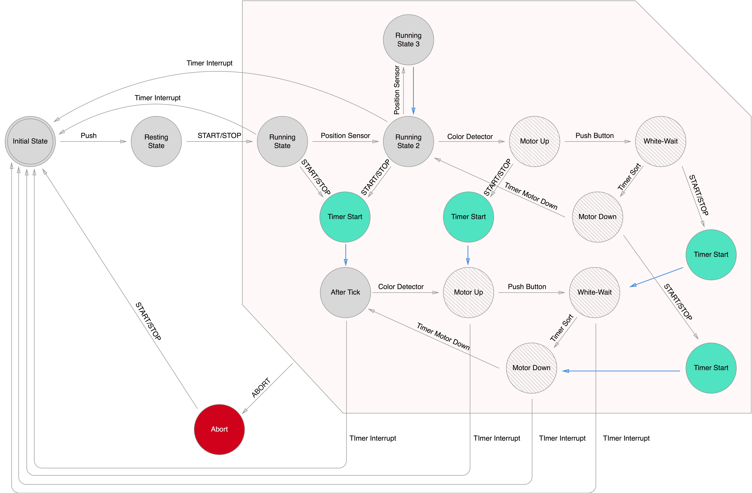

UPPAAL model
[Insert UPPAAL model here]

Validation and Testing
[Insert validation and testing here]

